|  |  |
| --- | --- |
| Program No | 6 |
| Roll No | 1333 |
| Unit | Unit 2 |
| Program | Linear Search |

**Source Code:**

#include<iostream> using namespace std;

int main()

{

int n, arr[20], key; int i, flag=0;

cout << "***Linear search***" << endl << endl; cout << "Enter the size of the array: ";

cin >> n;

cout << "Enter the elements: " << endl; for(i=0; i<n; i++)

{

cin >> arr[i];

}

cout << "Enter the target value: " ; cin >> key;

for(i=0; i<n; i++)

{

if(arr[i] == key)

{

flag = 1; break;

}

}

if(flag == 1)

{

cout << "Target value " << key << " is found at index " <<i;

}

else

{

cout << "Target value is not found";

}

}//end of main

**Output:**

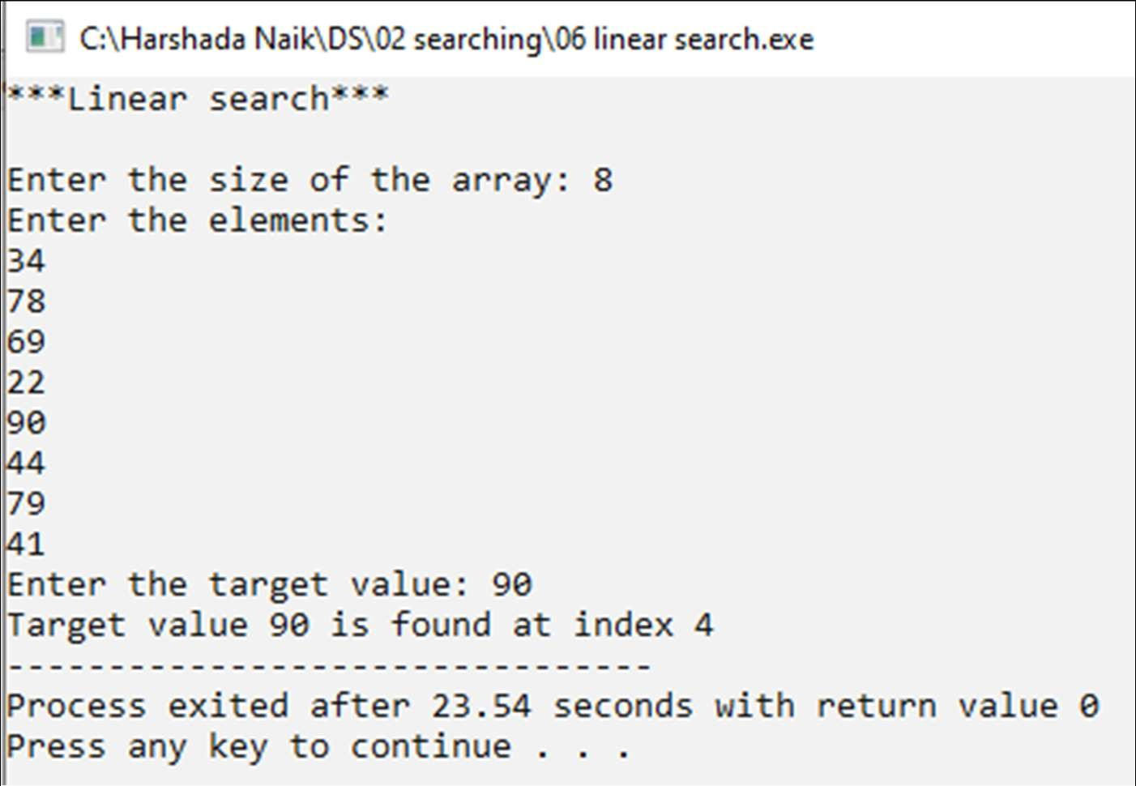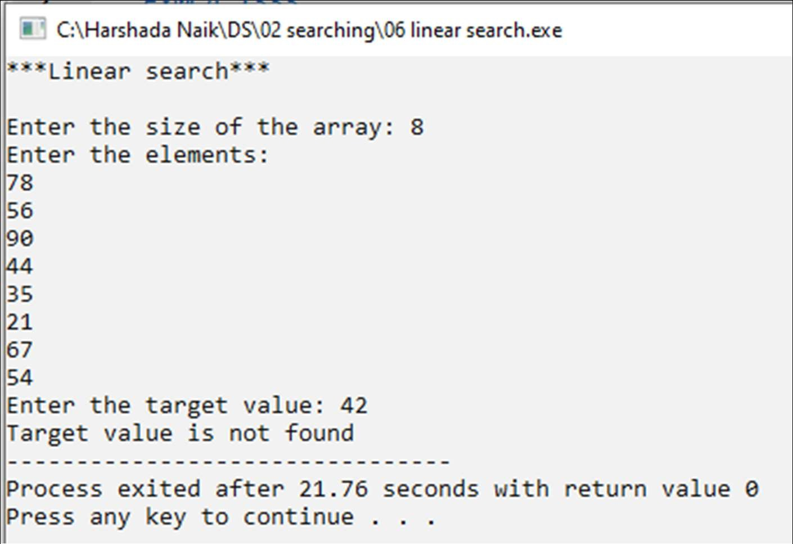

|  |  |
| --- | --- |
| Program No | 7 |
| Roll No | 1333 |
| Unit | Unit 2 |
| Program | Binary Search |

**Source Code:**

#include<iostream> using namespace std;

int main()

{

int n, arr[20], key; int i;

int first, last, mid, flag=0;

cout << "***Binary Search***" << endl << endl; cout << "Enter the size of array: ";

cin >> n;

cout << "Enter the elements in sorted array: " << endl; for(i=0; i<n; i++)

{

cin >> arr[i];

}

cout << "Enter the key: "; cin >> key;

first = 0; last = n-1;

while(first <= last)

{

mid = (first+last)/2;

if(key < arr[mid])

{

last = mid-1;

}

else if(key > arr[mid])

{

first = mid+1;

}

else //key is found!

{

flag = 1; break;

}

}//end of while

if(flag == 1)

{

}

else

{

}

cout << "key " << key << " is found at index " << mid;

cout << "key " << key << " is not found";

}//end of main

**Output:**

